**InsightStream: Navigate the News Landscape**

**Ideation Phase**

**Brainstorm & Idea Prioritization**

|  |  |
| --- | --- |
| Date | 31 January 2025 |
| Team ID | SWTID1741257268149879 |
| Project Name | InsightStream: Navigate the News Landscape |
| Maximum Marks | 4 Marks |

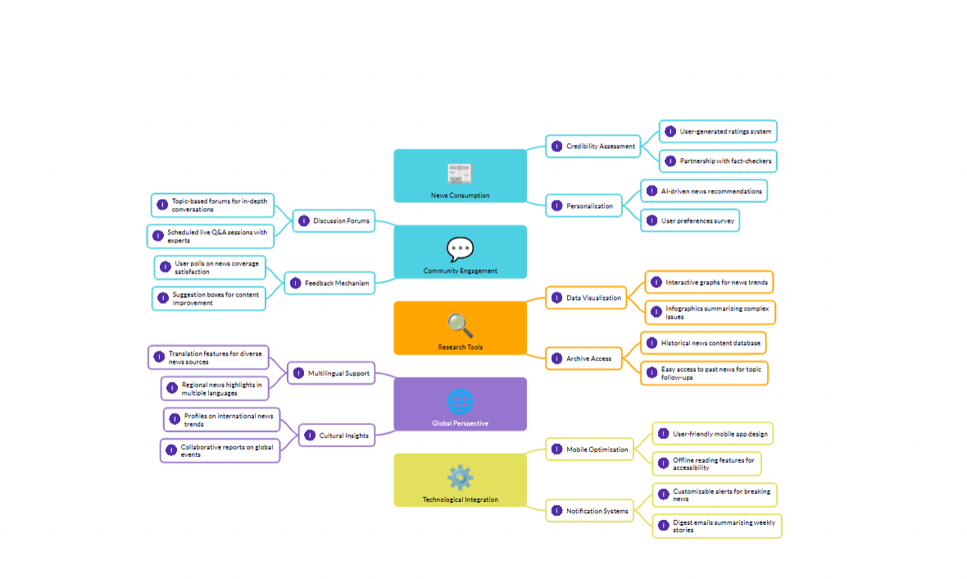**Step-1: Team Gathering, Collaboration and Select the Problem Statement**

**Enhancing News Consumption and Engagement through Technological Integration**

### ****1. News Consumption****

#### ****Credibility Assessment****

* Implementing a **user-generated ratings system** to evaluate news reliability.
* Establishing partnerships with **fact-checkers** to ensure accurate reporting.

#### ****Personalization****

* Utilizing **AI-driven news recommendations** tailored to individual preferences.
* Conducting **user preference surveys** to refine content suggestions.

### ****2. Community Engagement****

#### ****Discussion Forums****

* Providing **topic-based forums** for in-depth discussions on current events.
* Hosting **scheduled live Q&A sessions** with experts to enhance understanding.

#### ****Feedback Mechanism****

* Encouraging **user polls** on news coverage satisfaction.
* Implementing **suggestion boxes** for continuous content improvement.

### ****3. Research Tools****

#### ****Data Visualization****

* Developing **interactive graphs** to track news trends visually.
* Creating **infographics** to simplify complex issues for readers.

#### ****Archive Access****

* Maintaining a **historical news content database** for reference.
* Ensuring **easy access to past news** for topic follow-ups.

### ****4. Global Perspective****

#### ****Multilingual Support****

* Offering **translation features** for diverse news sources.
* Providing **regional news highlights** in multiple languages.

#### ****Cultural Insights****

* Curating **profiles on international news trends** for broader perspectives.
* Facilitating **collaborative reports** on global events.

### ****5. Technological Integration****

#### ****Mobile Optimization****

* Designing a **user-friendly mobile app** for seamless news access.
* Implementing **offline reading features** for enhanced accessibility.

#### ****Notification Systems****

* Enabling **customizable alerts** for breaking news updates.
* Sending **digest emails** summarizing weekly top stories.

By incorporating these strategies, news platforms can provide a more engaging, credible, and personalized experience for users, ensuring that they stay informed with accurate and relevant news content.

**Step-2: Brainstorm, Idea Listing and Grouping**

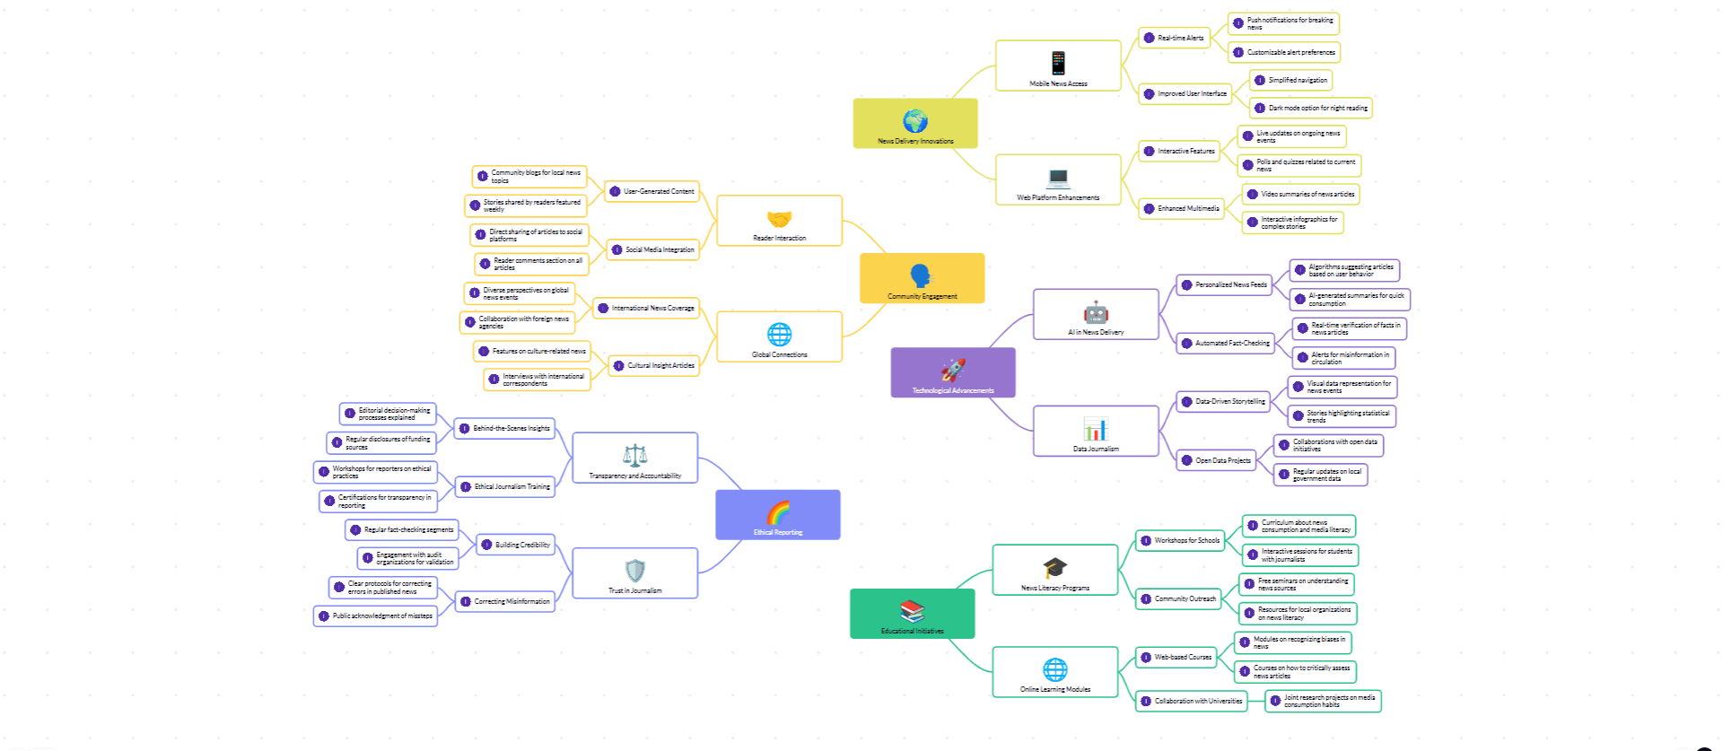

**Step-3: Idea Prioritization**

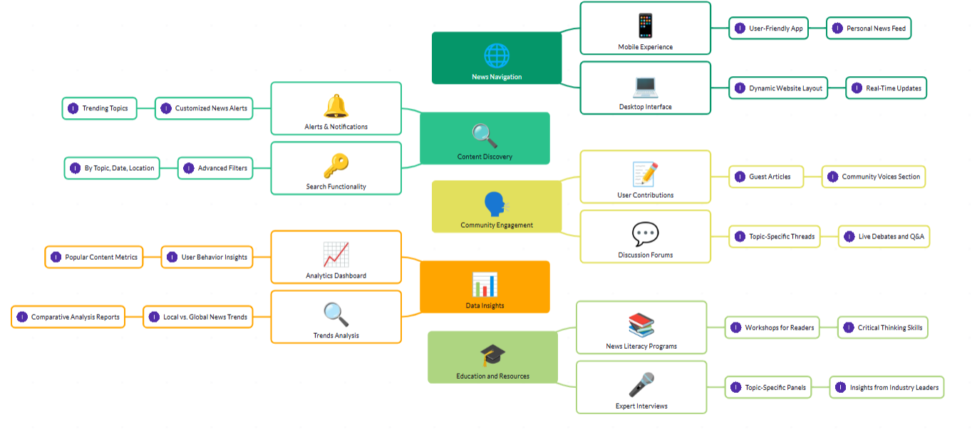

**Enhancing News Consumption and Engagement through Technological Integration**

### ****1. News Consumption****

#### ****Credibility Assessment****

* Implementing a **user-generated ratings system** to evaluate news reliability.
* Establishing partnerships with **fact-checkers** to ensure accurate reporting.

#### ****Personalization****

* Utilizing **AI-driven news recommendations** tailored to individual preferences.
* Conducting **user preference surveys** to refine content suggestions.

### ****2. Community Engagement****

#### ****Discussion Forums****

* Providing **topic-based forums** for in-depth discussions on current events.
* Hosting **scheduled live Q&A sessions** with experts to enhance understanding.

#### ****User Contributions****

* Encouraging **guest articles** for diverse viewpoints.
* Creating a **community voices section** for open discussions.

#### ****Feedback Mechanism****

* Encouraging **user polls** on news coverage satisfaction.
* Implementing **suggestion boxes** for continuous content improvement.

### ****3. Research Tools****

#### ****Data Visualization****

* Developing **interactive graphs** to track news trends visually.
* Creating **infographics** to simplify complex issues for readers.

#### ****Archive Access****

* Maintaining a **historical news content database** for reference.
* Ensuring **easy access to past news** for topic follow-ups.

### ****4. Global Perspective****

#### ****Multilingual Support****

* Offering **translation features** for diverse news sources.
* Providing **regional news highlights** in multiple languages.

#### ****Cultural Insights****

* Curating **profiles on international news trends** for broader perspectives.
* Facilitating **collaborative reports** on global events.

### ****5. Technological Integration****

#### ****News Navigation****

* **Mobile Experience:** Designing a **user-friendly mobile app** with a **personalized news feed**.
* **Desktop Interface:** Implementing a **dynamic website layout** with **real-time updates**.

#### ****Content Discovery****

* **Alerts & Notifications:** Featuring **trending topics**, **customized news alerts**, and **advanced filters**.
* **Search Functionality:** Allowing searches by **topic, date, and location** for efficient news discovery.

#### ****Analytics Dashboard****

* Tracking **popular content metrics** and **user behavior insights**.
* Conducting **comparative analysis reports** on local vs. global news trends.

#### ****Trends Analysis****

* Identifying **emerging trends** and monitoring news engagement patterns.

### ****6. Education and Resources****

#### ****News Literacy Programs****

* Organizing **workshops for readers** to enhance **critical thinking skills**.

#### ****Expert Interviews****

* Hosting **topic-specific panels** and gaining **insights from industry leaders**.

By incorporating these strategies, news platforms can provide a more engaging, credible, and personalized experience for users, ensuring that they stay informed with accurate and relevant news content.